Experiment 6: Digital Evidence Collection Using FTK Imager
Course: Incident Response and Management (IRM) Programme: Final Year B.Tech – Computer Science and Engineering Experiment Title: Digital Evidence Collection Using FTK Imager
1. Aim
To acquire digital evidence, create a forensic disk image, verify its integrity using hash values, and understand evidence preservation procedures using FTK Imager.
2. Objectives
- Understand the process of digital evidence acquisition.
- Create a forensic image of a storage device or a sample evidence file.
- Generate and verify cryptographic hash values such as MD5 and SHA-256.
- Examine files and metadata using FTK Imager.
- Understand chain of custody and the preservation of digital evidence.
3. Software and Hardware Requirements
Component | Requirement
Operating system | Windows 10/11
Software | FTK Imager
Storage media | USB drive or instructor-provided sample disk image
Storage space | Sufficient free space to store the forensic image
Hash algorithms | MD5 and SHA-256
Privileges | Administrator access, if required
Important safety instruction: For classroom practice, use a dedicated USB drive containing sample files or a provided disk image. Do not use your personal drive or a drive containing important data. Never format, initialize, or write to the original evidence device. For actual forensic investigations, use a validated hardware write blocker wherever applicable.
4. Theory
FTK Imager is a digital forensic acquisition and preview tool used to examine storage media, create forensic images, and preserve digital evidence for investigation.
A forensic image is a bit-by-bit copy of a storage device or a logical copy of selected data, depending on the acquisition method. It allows investigators to examine evidence while minimizing the need to work directly on the original source.
Important concepts:
- Digital evidence: Electronic information that may be relevant to an investigation.
- Forensic image: A copy of storage data created for forensic examination.
- Hash value: A fixed-length digital fingerprint used to check whether data has changed.
- Evidence integrity: Assurance that evidence remains unchanged and reliable.
- Chain of custody: A documented record of who collected, handled, transferred, stored, or examined the evidence.
5. Procedure: Step-by-Step Practical
Part A: Prepare the Evidence
Step 1: Create sample evidence files
- Create a folder on your desktop named IRM_Evidence.
- Inside the folder, create three sample files:
  - Incident_Report.txt
  - Network_Log.txt
  - Readme.txt
- Add fictional incident details to these files. Do not use real personal or confidential information.
- Copy the folder to a dedicated USB drive prepared for this practical.
- Note the date, time, device make/model, and available device identifier.
Step 2: Download and launch FTK Imager
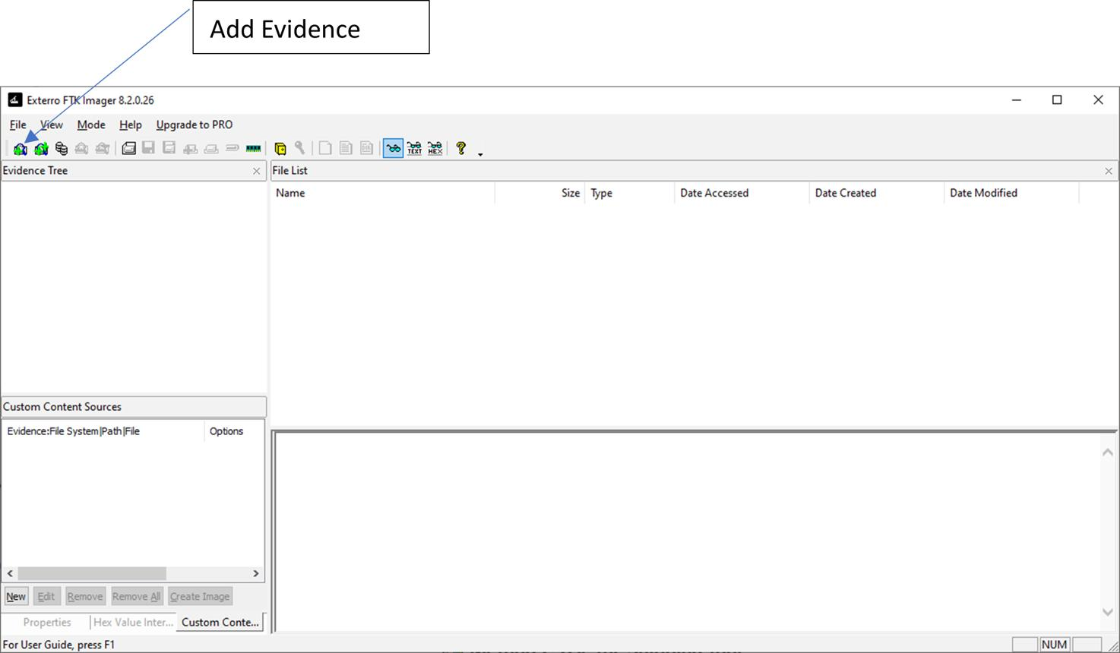
- Download FTK Imager from the official Exterro website.
- Install the application according to your institution's software policy.
- Connect the prepared USB drive.
- Launch FTK Imager, using administrator privileges if required.
- Confirm that the application opens correctly.
Official website: FTK Imager
Part B: Identify and Preview the Evidence
Step 3: Add the evidence device
- Open FTK Imager.
- Select File → Add Evidence Item.
- Choose Physical Drive to inspect the entire device, or Logical Drive to inspect a mounted volume.
- Click Next.
- Select the correct USB drive or volume from the list.
- Click Finish.
- Examine the evidence tree displayed in the left pane.
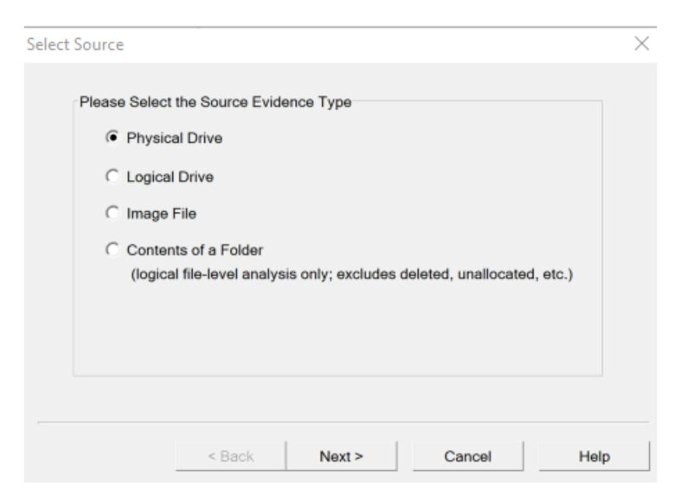
ajcs01.github.io
Observation: The selected device should appear in the evidence tree. Confirm the device details and drive identity before proceeding.
Step 4: Preview files and metadata
- Expand the device and its partitions or volumes.
- Navigate to the folder containing the sample evidence.
- Select Incident_Report.txt.
- Examine its contents in the viewer pane.
- Inspect available file metadata, such as filename, size, timestamps, and other displayed attributes.
- Repeat for the other sample files.
- Record the observations in your practical journal.
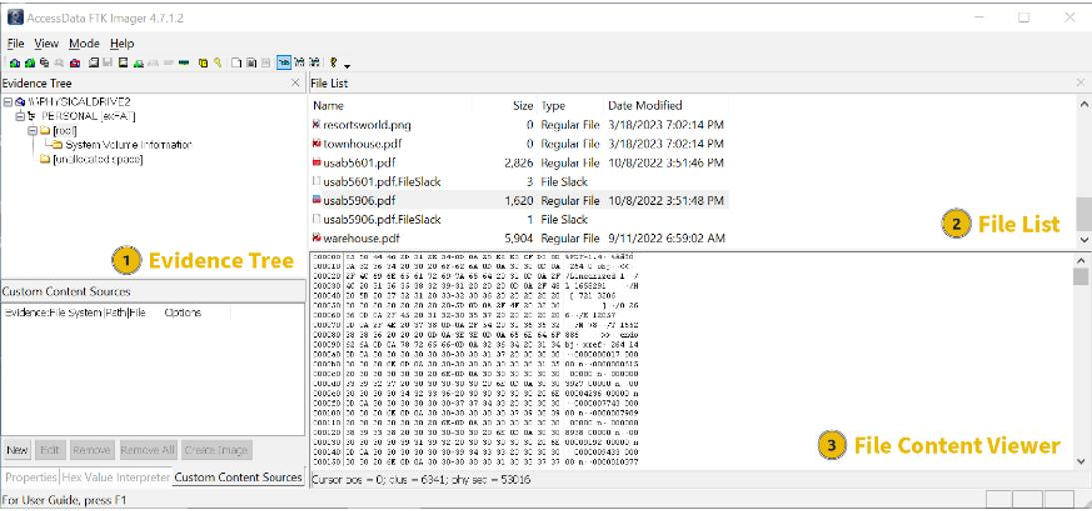
medium.com
Observation: FTK Imager should display accessible files and their contents. The files visible depend on the selected evidence source and supported file system.
Part C: Create a Forensic Disk Image
Step 5: Start the acquisition process
- Select File → Create Disk Image.
- Choose the appropriate source type:
  - Physical Drive: For acquisition of the entire storage device.
  - Logical Drive: For acquisition of a selected logical volume.
  - Image File: To create a copy or derivative from an existing forensic image.
- Click Next.
- Select the prepared USB device or intended source.
- Verify the selected device carefully.
- Click Finish or proceed to the next screen, depending on the application version.
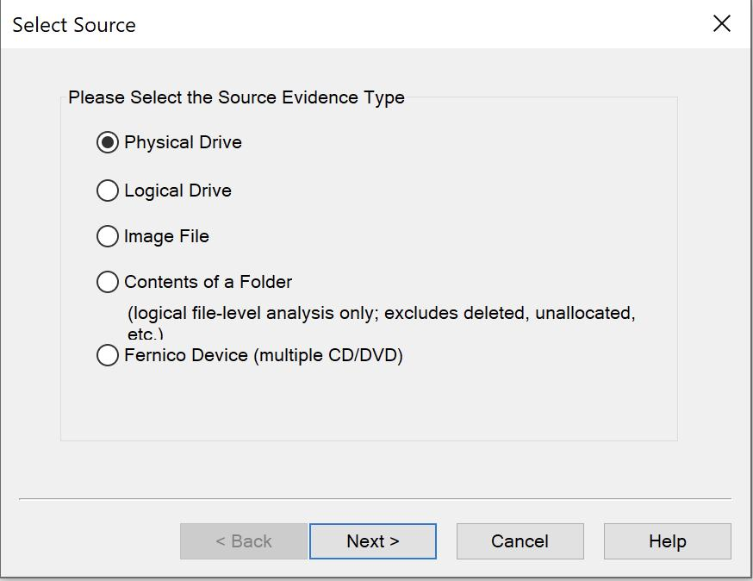
not2clever.me
Step 6: Select the image format
- In the Create Image dialog, click Add.
- Select the image type supported by your version of FTK Imager.
Format | Description
E01 | EnCase evidence format; supports case information and commonly supports compression
Raw (dd) | Raw bitstream image without an evidence-container header
AFF | Advanced Forensic Format, if supported by the installed version
3. Click Next.
Recommendation: Use E01 for this practical if available because it supports evidence metadata and verification features. Raw (dd) is also suitable for demonstrating forensic imaging.
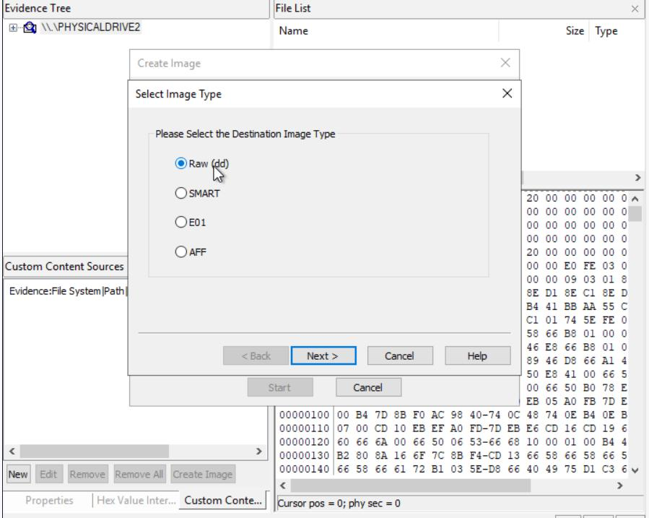
medium.com
Step 7: Enter case and evidence information
Enter suitable details in the image destination fields. The exact fields may vary by version.
Field | Example
Case Number | IRM-EXP-06
Evidence Number | EVD-001
Unique Description | Training USB Evidence
Examiner | Student ID or examiner initials
Notes | Classroom forensic acquisition
Destination Folder | D:\IRM_Practical\Case06
- Create the destination folder on a separate storage drive.
- Do not save the forensic image to the original evidence USB.
- Select the image destination and enter a filename such as USB_Evidence.E01.
- Check that the destination has sufficient free space.
- Review the source and destination once more.
- Start the acquisition.
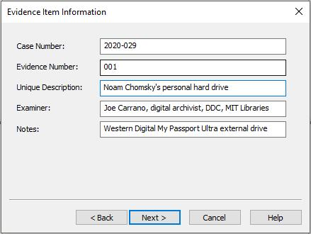
wikis.mit.edu
Step 8: Acquire the evidence
- Click Start or the corresponding acquisition button.
- Allow FTK Imager to read the source and create the forensic image.
- Do not disconnect the device or interrupt the process.
- Monitor the acquisition progress.
- Wait until the process finishes.
- Record the completion status and any warnings or errors.
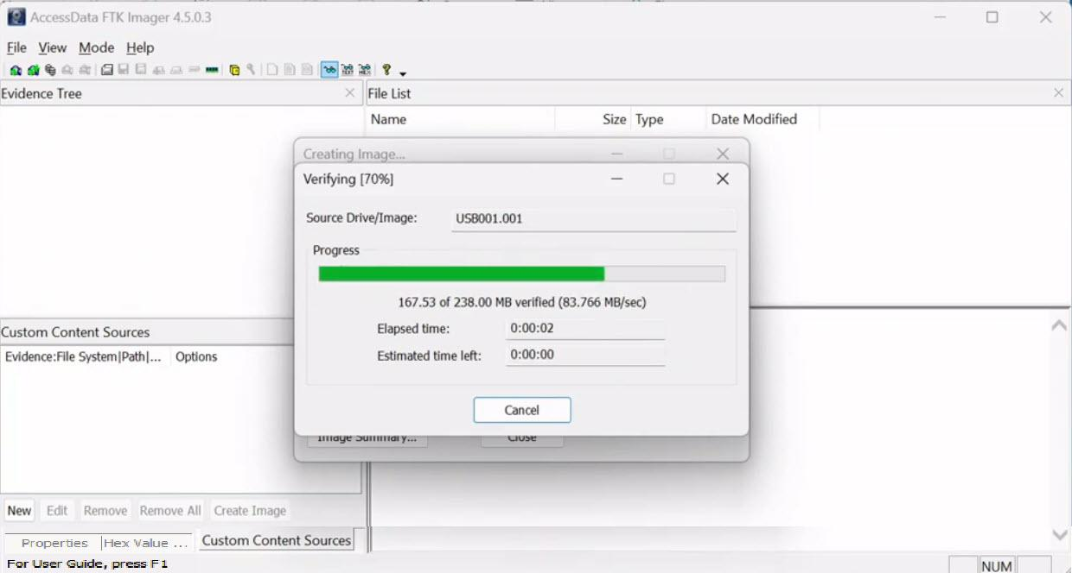
smartprofix.com
Expected result: The forensic image is created in the selected destination folder. Its extension may be .E01 for E01 format or .dd for a raw image.
Part D: Verify Evidence Integrity
Step 9: Enable image verification
During image creation, enable the option to verify the images after they are created, if available.
- Check the Verify images after they are created option.
- Start or continue the acquisition.
- Wait for the verification process to complete.
- Examine the reported verification status.
- Record the source and image hash values displayed by the application, along with the algorithm used.
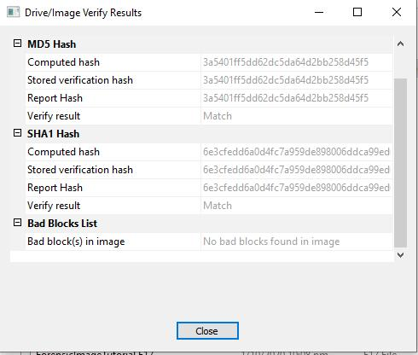
rorywag.gitbook.io
Step 10: Understand hash verification
A hash algorithm produces a fixed-length value based on the input data.
- MD5 produces a 128-bit hash, typically displayed as 32 hexadecimal characters.
- SHA-256 produces a 256-bit hash, typically displayed as 64 hexadecimal characters.
If the relevant source and acquired-image hash values match under the same algorithm and scope, this supports the conclusion that the acquired data matches the data that was hashed.
Important: Not all acquisition methods or FTK Imager versions expose the same hash options. Record the algorithm actually used; do not assume that SHA-256 was calculated merely because verification succeeded.
For an additional SHA-256 check on Windows, open PowerShell and run:
Get-FileHash "D:\IRM_Practical\Case06\USB_Evidence.E01" -Algorithm SHA256
This computes the SHA-256 hash of the E01 container file, not necessarily the hash of the original device's acquired data. These are different verification scopes.
Part E: Examine the Acquired Image
Step 11: Load the forensic image
- Select File → Add Evidence Item.
- Choose Image File.
- Click Next.
- Browse to the created .E01 or .dd file.
- Select the file and click Finish.
- Expand the loaded image in the evidence tree.
- Navigate to the partition or file system, where available.
- Locate the three sample evidence files.
- Open the files and compare their contents with your original sample files.
- Record the findings.
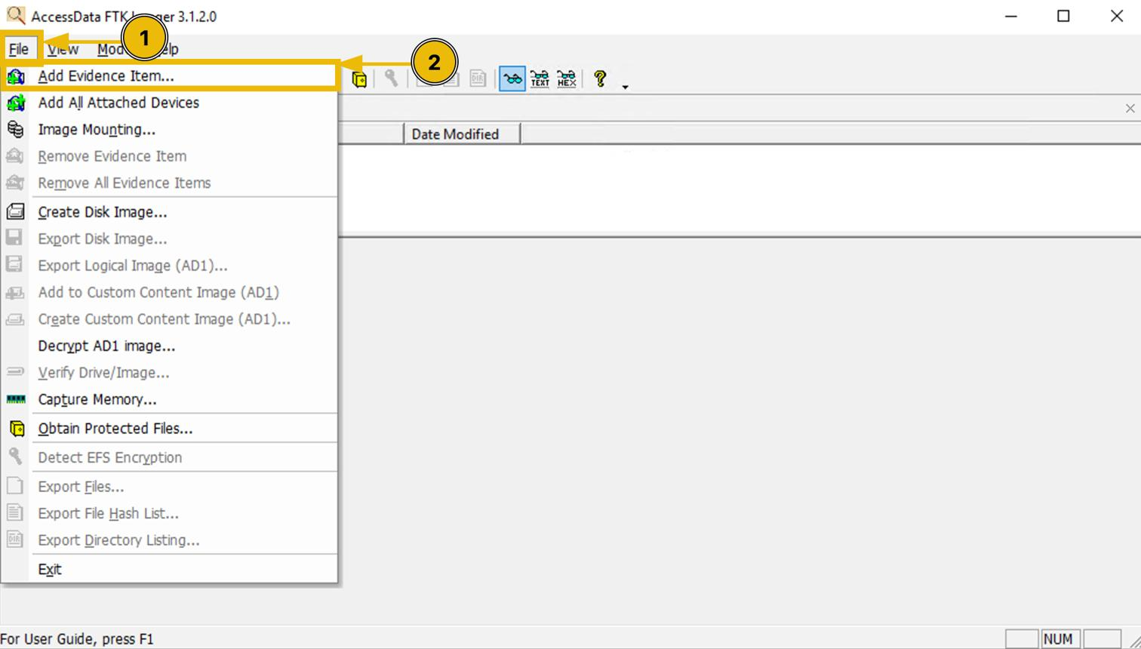
tryhackme.com
Step 12: Export a selected evidence file (optional)
- Select a sample file in the evidence tree.
- Right-click and select Export Files, or use the equivalent menu option.
- Select a separate output folder.
- Export the file.
- Compare its contents with the original sample file.
- If required, compute SHA-256 hashes of the original and exported files and compare them.
Do not confuse a hash of an exported file with a hash of the complete forensic image.
Part F: Preserve and Document the Evidence
Step 13: Maintain the chain of custody
Complete a record like the following using actual details from your practical.
Field | Details to record
Case ID | IRM-EXP-06
Evidence ID | EVD-001
Description | Training USB Evidence
Collected by | Student/examiner details
Collection date and time | Actual date and time
Device identifier | Actual make/model and identifier
Image filename | USB_Evidence.E01
Acquisition method | Physical or logical
Hash algorithm | Algorithm actually used
Verification result | Actual result
Storage location | Actual destination
Transfer history | Date, time, person, purpose, signatures
- Save the acquisition and verification logs, if generated.
- Keep the original source secure.
- Store the forensic image in a controlled location.
- Restrict access to authorized personnel.
- Record every evidence transfer or examination.
- Avoid modifying the original evidence.
6. Observation Table
Fill in the table using the actual output obtained during the experiment.
Sr. No. | Observation | Result
1 | Source device detected | __________
2 | Number of sample files observed | __________
3 | Forensic image created | Yes / No
4 | Image filename and format | __________
5 | Image verification completed | Yes / No
6 | Hash algorithm used | __________
7 | Source/image verification result | __________
8 | Sample files accessible from image | Yes / No
9 | Chain-of-custody record completed | Yes / No
7. Expected Output
At the end of the experiment, students should have:
- A forensic image of the selected training device or volume.
- A record of the source device and acquisition parameters.
- The hash and verification results reported by FTK Imager.
- A preview of the files and metadata available in the image.
- A completed observation table and chain-of-custody record.
8. Result
The digital evidence acquisition experiment was performed using FTK Imager. A forensic image was created from the selected training evidence source, and the available verification process was used to assess its integrity. The image was loaded for examination, sample files were inspected, and evidence preservation procedures were documented.
Students should modify this result according to the actual acquisition and verification outcome. Do not report successful verification if the tool returned a failure or the verification was not performed.
9. Viva-Voce Questions
- What is digital evidence?
- What is FTK Imager, and why is it used in digital forensics?
- What is the difference between a physical drive and a logical drive?
- What is a forensic disk image?
- Differentiate between E01 and Raw (dd) formats.
- What is the purpose of hashing in digital forensics?
- What is the difference between MD5 and SHA-256?
- Why should investigators use a write blocker?
- What is the chain of custody, and why is it important?
- Why should the forensic image be stored separately from the original evidence?
- Does matching a container-file hash prove that the entire acquisition process was forensically sound? Explain.
- What should an investigator do if verification fails?

